**3.11 Lesson**

**Name (print first and last) _____________________________________ Per_____ Date:** 10/31 due 11/1

**3.11 Rigid Transformations: Congruence Geometry Regents 2013-2014 Ms. Lomac**

SLO: I can explain the relationship between rigid motions and congruence and the role of correspondence.

(1) ⬜ Construct the perpendicular bisector of to verify (check) that R is the midpoint of . Constructing the perpendicular bisector of  supports the claim that R is the midpoint of  because _________________________________________________________________________________________________________________________________________________________________________________

**R**

**W**

**K**

(2) ⬜ **Correspondence** can be thought of as a “pairing” of points between two shapes. List a few everyday objects that come in pairs. ___________________________ ___________________________ ___________________________

(a) ⬜ Are pairs of everyday objects always identical/congruent?

(b) ⬜ Think about a pair of shoes. What part of the right shoe corresponds to the given part of the left shoe?

**Left Shoe:** Lace Sole Tongue Velcro

**Right Shoe: ____________ ____________ ____________ ____________**

(c) ⬜ The right lace does/does not have to be exactly the same as the left because _________________________

____________________________________________________________________________________

(3) ⬜ Like the shoes, corresponding parts of figures do not have to be exactly the same – congruent – however, they always will be when a figure undergoes a rigid transformation because _______________________________________ __________________________________________________________________________________________________

(4) ⬜ In the figure below, the left figure has been mapped to the one on the right by a rotation of 240° around point P.

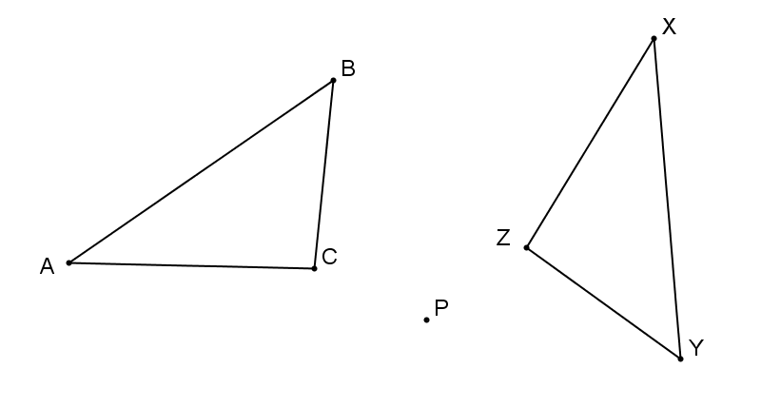Point _____ corresponds to point _____

Point _____ corresponds to point _____

Point _____ corresponds to point _____

Segment _____ corresponds to segment _____

Segment _____ corresponds to segment _____

Segment _____ corresponds to segment _____

Angle ________ corresponds to angle _________

Angle ________ corresponds to angle _________

Angle ________ corresponds to angle _________

Write the abbreviation (function notation) for the transformation __________________________

3.11

(5) ⬜ The triangles in the figure below are congruent by a _____° rotation around the midpoint (not drawn) of . List the corresponding sides and angles.

Sides: _______ _______, _______ _______, _______ _______

Angles: _______ _______, _______ _______, _______ _______

Are the corresponding parts congruent?_______ because ___________________

_________________________________________________________________

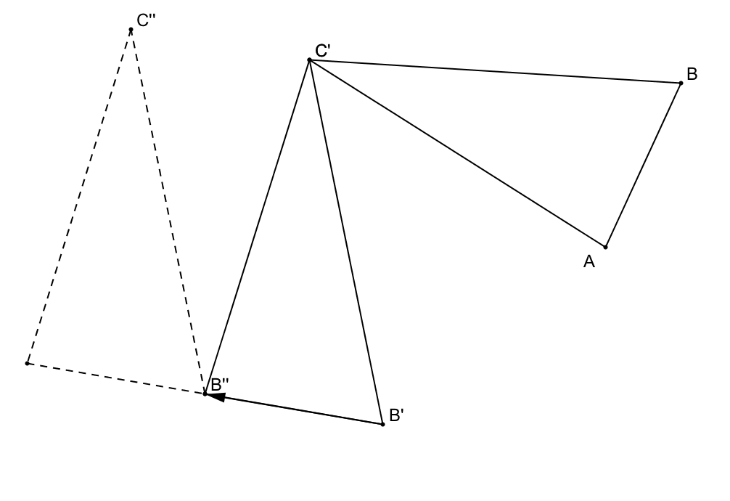

(6) ⬜ Below is a composition of transformations.

A''

(a) ⬜ Describe the transformations _______________________________________________________________

__________________________________________________________________________________________

(b) ⬜ State the composition of transformations in function notation ___________________________

(c) ⬜ List each set of corresponding sides

_______ _______ _______, _______ _______ _______, _______ ______ _______

(d) ⬜ List each set of corresponding angles

_______ _______ _______, _______ _______ _______, _______ ______ _______

(e) ⬜ Circle the correct congruence statement and explain why it is the correct statement.

  

__________________________________________________________________________________________

(7) All of the triangles in the diagram below are congruent. Choose a triangle to be the original figure and then write a composition of transformations that will map the triangle you chose onto another triangle in the figure. Your composition must use the other 2 triangles in the diagram as steps to get to the final image.

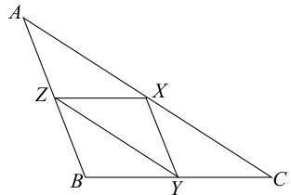

M

Describe: ________________________________________________________

________________________________________________________________

________________________________________________________________

________________________________________________________________

________________________________________________________________

________________________________________________________________

________________________________________________________________

Composition in function notation: ________________________________________________________________

**3.11 HW**

**Name (print first and last) _____________________________________ Per_____ Date:** 10/31 due 11/1

**3.11 Rigid Transformations: Congruence Geometry Regents 2013-2014 Ms. Lomac**

⬜ For each diagram below, (a) Describe the composition of transformations, (b) Write the composition of transformations in function notation, (c) Write a congruence statement from the original to the final image.

(1)

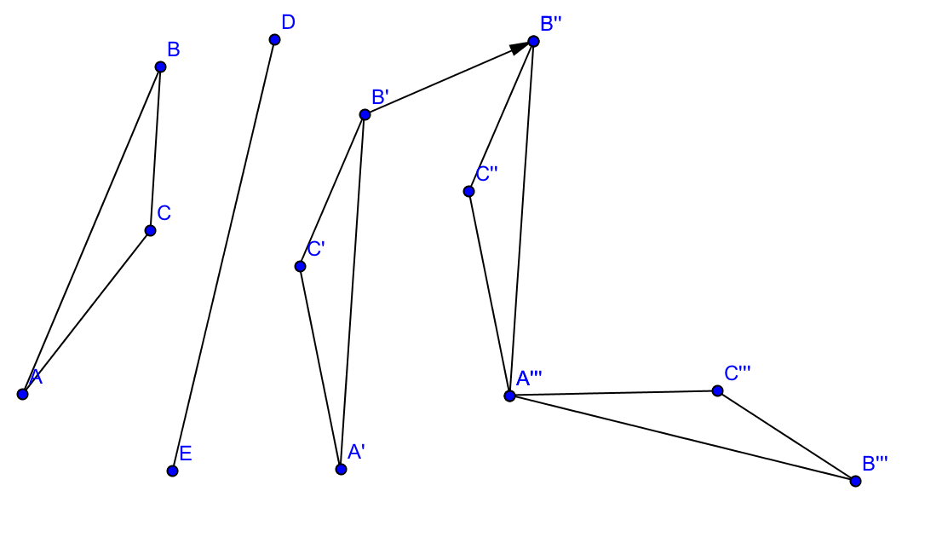_________________________________________________________________________________________________

_________________________________________________________________________________________________.

_________________________________________________________________________________________________.

_________________________________________________________________________________________________.

_________________________________________________________________________________________________.

_________________________________________________________________________________________________.

_________________________________________________________________________________________________.

_________________________________________________________________________________________________.

_________________________________________________________________________________________________.

_________________________________________________________________________________________________.

_________________________________________________________________________________________________.

_________________________________________________________________________________________________.

_________________________________________________________________________________________________.

_________________________________________________________________________________________________.

_________________________________________________________________________________________________.

_________________________________________________________________________________________________.

(2)

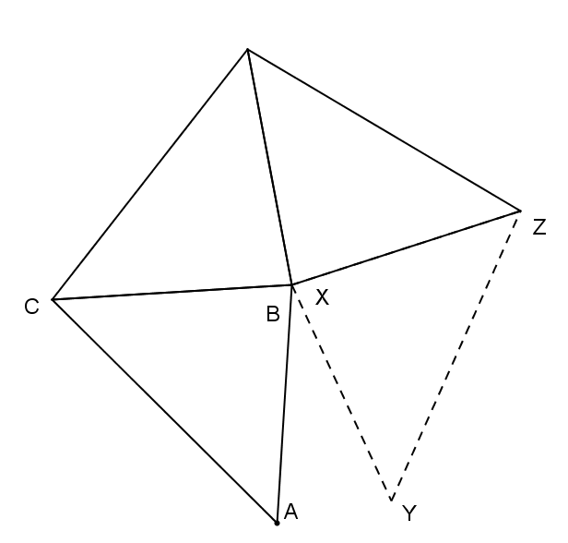_________________________________________________________________________________________________

_________________________________________________________________________________________________.

_________________________________________________________________________________________________.

_________________________________________________________________________________________________.

_________________________________________________________________________________________________.

_________________________________________________________________________________________________.

_________________________________________________________________________________________________.

_________________________________________________________________________________________________.

_________________________________________________________________________________________________.

_________________________________________________________________________________________________.

_________________________________________________________________________________________________.

_________________________________________________________________________________________________.

_________________________________________________________________________________________________.

_________________________________________________________________________________________________.

_________________________________________________________________________________________________.

_________________________________________________________________________________________________.

3.11 Exit Ticket Name_________________________________________Per______

**In square ABCD, diagonal AC is drawn. The triangles are reflections.**

⬜ q I got this! L

⬜ 7 I can with a bit of help M

⬜ w I will, given lots of help

⬜ h I can’t a

⬜ 8 I won’t bother to B

⬜ P I refuse to E

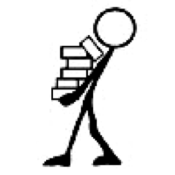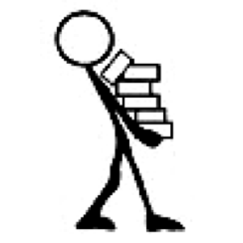



Write a congruence statement for the triangles: ____________________

Write the function notation for the reflection: _________________________

3.11 Exit Ticket Name_________________________________________Per______

**In square ABCD, diagonal AC is drawn. The triangles are reflections.**

⬜ q I got this! L

⬜ 7 I can with a bit of help M

⬜ w I will, given lots of help

⬜ h I can’t a

⬜ 8 I won’t bother to B

⬜ P I refuse to E





Write a congruence statement for the triangles: ____________________

Write the function notation for the reflection: _________________________

3.11 Exit Ticket Name_________________________________________Per______

**In square ABCD, diagonal AC is drawn. The triangles are reflections.**

⬜ q I got this! L

⬜ 7 I can with a bit of help M

⬜ w I will, given lots of help

⬜ h I can’t a

⬜ 8 I won’t bother to B

⬜ P I refuse to E





Write a congruence statement for the triangles: ____________________

Write the function notation for the reflection: _________________________

3.11 Exit Ticket Name_________________________________________Per______

**In square ABCD, diagonal AC is drawn. The triangles are reflections.**

⬜ q I got this! L

⬜ 7 I can with a bit of help M

⬜ w I will, given lots of help

⬜ h I can’t a

⬜ 8 I won’t bother to B

⬜ P I refuse to E





Write a congruence statement for the triangles: ____________________

Write the function notation for the reflection: _________________________