|  |
| --- |
| **1) d = vi*t + 1/2 a*t2**  **2) Vf = Vi + a*t**  **3) Vf2 = Vi2 + 2*a*d** |

1. 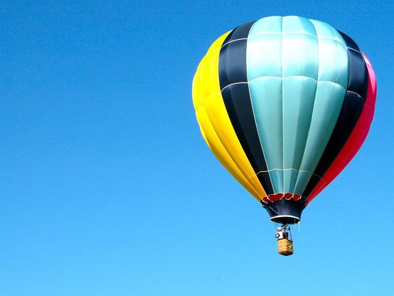A man is being lifted in a hot air balloon at the rate of 5.00 m/s when he drops his cell phone at a height of 235 m.
   1. Where will the cell phone be after 2 sec?
   2. What is its velocity after 2 sec?
   3. Where will the be after 30 sec?



5.00 m/s



1. Two carriages are separated but are moving toward each other on the same track. One carriage is moving at 35.4 m/s while the other accelerates at 2.00 m/s2 from rest. After 3 seconds
   1. At what point will they be?
   2. How fast will each of them be moving?



1. A runner is moving at a constant speed of 3.50 m/s for 20 sec when she accelerates over the next 55.0 meters to 5.60 m/s .
   1. What acceleration was produced and how long does it take her to speed up from 3.50 to 5.60 m/s?
   2. On the graphs (attached to the reference page), Plot distance and Velocity for this motion.



1. A police car is watching a train traveling by at intersection when he notices the end shows significant damage at the end so he tells the train’s driver to stop. The train is 1.12 Km long. The patrolman has an old Ford Focus which can accelerates from rest at 0.56 m/s2.
   1. How long will it take the driver to reach the front of the train?
   2. What will be his speed after the 1.12 Km assuming he accelerates uniformly?

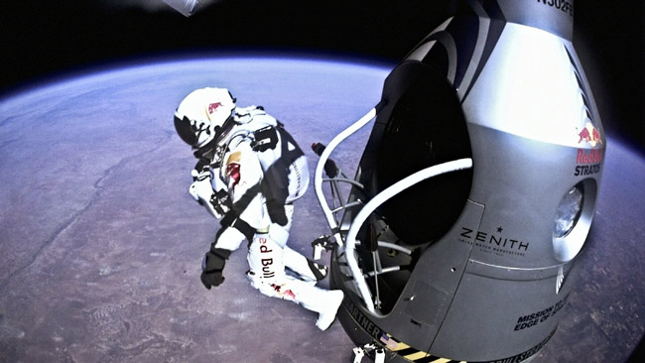

1. Felix Baugartner set a world record by skydiving from 39,000 meters above the earth. It he did not have a terminal velocity,
   1. How long would it take him to fall
   2. how fast would he be falling at that time.